

**Independent University, Bangladesh**

**An Undergraduate Internship /Project on**

**“Web Application on Farmer Assisting Site”**

**By**

K.M.Ashik Alam Simanto

Student ID: 1620308

Spring, 2021

Supervisor:

**Subrata Kumar Dey**

Internship Supervisor & Senior Lecturer

Department of Computer Science and Engineering School of Engineering & Computer Science Independent University, Bangladesh.

Summer, 2021

**Dissertation submitted in partial fulfillment for the degree of Bachelor of Science in**

**Computer Science**

**Department of Computer Science & Engineering**

**Independent University, Bangladesh**

# Attestation

I, K.M. Ashik Alam Simanto, hereby certify that none of the work that has been done in this report is plagiarized or copied from anywhere. Any resources used are mentioned in the reference section of the report. No help was asked for during the completion of the report from a third party organization except the one that I have worked for in the last 3 months as an intern.

For any information, my internship supervisor, Mahtab Uddin Khan, at my company, Bengal

Software Limited, can be contacted on 01816811482

Sincerely



K.M. Ashik Alam Simanto

1st May, 2021

# ACKNOWLEDGEMENTS

At first, I would like to thank Almighty ALLAH for giving me the endurance and the ability to work hard. It is my privilege that I had the opportunity to do an internship in Bengal Software. I would like to thank all the people on whom I carry out my internship.

I express my deep gratefulness to my supervisor Subrata Kumar Dey, Senior Lecturer, Department of Computer Science and Engineering, Independent University, Bangladesh; for his invaluable instructions, continuous guidance, constructive criticisms and thoughtful advice during pursuing this internship and preparation of this report.

I also express my deep gratefulness to Mahtab U Khan (CEO, Bengal Software), MD. Abid Hossain (Project Manager, Bengal Software), Fahim Ashab (Product Manager, Bengal Software). I also, express my deep gratefulness to all employees of Bengal Software for cooperating and helping me to complete this internship report.

K.M. ASHIK ALAM SIMATO

ID: 1620308

Dhaka, Bangladesh

# Letter of Transmittal

1st May, 2021

Subrata Kumar Dey

Internship Supervisor & Senior Lecturer

Department of Computer Science and Engineering

School of Engineering, Technology and Sciences

Independent University, Bangladesh

Subject: Internship report on ‘Web application on Farmer Assisting Site’ for Bengal Software Limited.

Dear Sir,

It is my pleasure to submit to you my internship report on ‘Web application on Farmer Assisting Site’ for Bengal Software Limited. This report has been prepared based on my three month internship at Bengal Software Limited and the project that I had been working on during that time. The purpose of this report was to fulfill the requirements of the Bachelor degree of Computer Science and Engineering and also to gain an insight on how the organizations are dealing with the ongoing COVID-19 pandemic.

I tried to give my best effort to make this report successful. It has been an instructive and knowledgeable experience for me to work along with development team in Bengal Software Limited. I would be really happy if the report that I have created is able to serve its purpose. I am grateful to you for dedicating your valuable time, expertise, guidance and support. I have tried my best to complete the report appropriately as much as possible. I would be available to explain any kind of queries related with my report anytime.

Thank you.

Yours sincerely,

K.M. ASHIK ALAM SIMANTO

ID: 1620308

# Evaluation Committee

.....................................................................

Signature

.....................................................................

Name

.....................................................................

Supervisor

.....................................................................

Signature

.....................................................................

Name

.....................................................................

Internal Examiner

.....................................................................

Signature

.....................................................................

Name

.....................................................................

External Examiner

.....................................................................

Signature

.....................................................................

Name

.....................................................................

# ABSTRACT

Farmers hold the backbone of the agricultural system. As it is common knowledge that for a country to progress the gross domestic product should be reasonable, agriculture is one of the important parts. The agricultural system will only run if there are crops being grown and harvested, so this where farmers come in.So if there was a site where farmers can easily sell and get contacted by the buyers it would be a great boost to the economy as these farmers will get more buyers and options to choose from where they can make the most profit. Websites have played a pivotal role and has profoundly changed our agricultural techniques and has provided the farmers with adequate data on their doorsteps. In a study It was predicted that it is of utmost importance to enhance the visualization and easy to handle websites with increased features. So our site will be very user friendly. It will have features like upload products, contacting with buyer, etc. In first chapter there is an introduction about the project, background of the project, objectives, scope of the project and about the organization where I worked. Chapter two describes the literature review where I discussed about market analysis both in local and global market, about similar products and how my undergraduate studies helps me to do this project. Chapter three describes the project management and financing of the project where I describes work breakdown structure, time distribution show in critical map diagram, gantt chart, activity wise resource allocation and about the budget. Chapter four describes about methodology where I describes about waterfall methodology which I used here, I also describe why use waterfall methodology. Chapter five describes body projects, where I describe in details about work description, six element analysis, feasibility analysis, problem, effects and constraints analysis. I also give here rich picture, erd diagram, activity diagram, use case diagram, sequence diagram and class diagram. Functional, nonfunctional requirements, input, output and architecture of the project also describes in this section. Chapter 6 describes about survey results and analysis. Chapter seven describes project as engineering problem analysis which includes sustainability of the project, social and environmental effects of the project, addressing ethics and ethical issues. Chapter eight describes about the future work for this project and finally the conclusion. This software will hopefully help a lot of farmers In need.

Table of Contents

Attestation ii

ACKNOWLEDGEMENTS iii

Letter of Transmittal iv

Evaluation Committee v

ABSTRACT vi

List of Figures xi

List of Tables xi

**Chapter 1 Introduction** 1

1.1 Overview/Background of the Work 1

1.1.1 Organization 2

1.1.2 Company profile 2

1.1.3 Products and services 2

1.2 Objectives 3

1.3 Scopes 3

**Chapter 2 Literature Review** 5

1.4 Relationship with Undergraduate Studies 5

1.5 Global Market 5

1.6 Related Journal Analysis 7

**Chapter 3 Project Management & Financing** 9

1.7 Work Breakdown Structure 9

1.8 Process/Activity wise Time Distribution 10

1.9 Gantt Chart 10

1.10 Process/Activity wise Resource Allocation 11

1.11 Estimated Costing 12

**Chapter 4 Methodology** 13

4.1 Why Agile for this project? 13

4.2 Agile Implementation 14

**Chapter 5 Body of the Project** 15

5.1 Work Description 15

5.2 Client Requirement Analysis 15

5.2.1 Introduction 15

5.2.2 Surveys & Questionnaire 16

5.2.3 Group Interviews 16

5.2.4 Prototype 16

5.2.5 Conclusion from Research and Analysis 17

5.2 System Analysis 18

5.2.1 Six Element Analysis 18

5.2.2 Feasibility Analysis 19

5.2.3 Problem Solution Analysis 19

5.2.4 Effect and Constraints Analysis 20

5.3 System Design 22

5.3.1 Rich Picture 22

5.3.2 UML Diagrams 22

5.3.3 Functional and Non-Functional Requirements 29

5.4 Product Features 31

5.4.1 Input 32

5.4.2 Output 33

5.4.3 Architecture 35

5.5 Test Case 35

5.5.1 Testing Strategy 36

5.5.2 Testing Analysis 37

**Chapter 6 Results & Analysis** 40

6.1 Overview 40

6.2 Results from interviews 40

6.3 Conclusion 40

**Chapter 7 Project as Engineering Problem Analysis** 42

7.1 Sustainability of the Project/Work 42

7.2 Social and Environmental Effects and Analysis 42

7.3 Addressing Ethics and Ethical Issues 42

**Chapter 8 Lesson Learned** 43

8.1 Problems faced during the project 43

8.2 Solution to those problems 43

**Chapter 9 Future Work & Conclusion** 44

9.1 Future Works 44

9.2 Conclusion 45

References 46

Appendix(UI image) 47

# List of Figures

Figure 3.1 1 Work Breakdown Structure 9

Figure 3.1 2 Time Distribution 10

Figure 3.1 3 Gantt Chart 11

Figure 4.1 1 Agile Development 13

Figure5.1 1 Rich Picture 22

Figure5.1 2 Entity relationship Diagram 23

Figure5.1 3 Activity Diagram for admin 24

Figure5.1 4 Activity Diagram for farmer 25

Figure5.1 5 Activity Diagram for buyer 26

Figure5.1 6 Use case diagram for admin 27

Figure5.1 7 Use case diagram for farmer 28

Figure5.1 8 Class Diagram 29

# List of Tables

Table 3.1 1 Cost Estimation 12

Table 5.1 1 Six Element Analysis 18

Table 5.1 2 Input tables with Field 33

Table 5.1 3 Output table with Field 34

Table 5.1 4 Test case 38

# **Chapter 1 Introduction**

Development of Web applications is the method and practice of designing web applications and their functionality. There is consensus that the processes involved are extensions of the normal processes of software engineering. Along with its unique features, common frameworks &amp; models are used in the creation of web applications. Internet application has become one of the most essential aspects of any company that has a number of members that are directly & indirectly affiliated with it as well as the new members who are eager to join.

The Internet communication network is the best way to introduce an organization, the organizations programs, and the organizations current and future knowledge to all its members as well as to the general public. To establish the legitimacy of the organization a web application plays a severe role. The following are the introduction that overlooks our topic on assisting farmers of Bangladesh.

## Overview/Background of the Work

The COVID-19 outbreak has affect the supply chains of farm businesses in Bangladesh. The farmers had never imagined a scenario like a global pandemic hitting Bangladesh, and the consequent imposition of a country-wide lockdown. Initially there was uncertainty about the regulations to come under lockdown, especially regarding the transport systems on which the organization so heavily depended. As more people were leaving Dhaka for their villages. There was also the possibility of potential food crisis looming in the city. The closure of markets and the initial transport bans presented a different set of challenges for farmers across the country. They were facing loss of income due to the lockdown. A farmer from the district of Jhinaidah, Alamgir, told that, “Before the pandemic, we would supply vegetables worth Tk. 20,000 to Dhaka every week that was transported by bus. But now we are no longer able to send supplies to Dhaka.” So,this projects goal is to avail a marketplace for the farmers that can help them selling their goods and help them continue their farmworks.

Internet access and agent technology promises to revolutionize the landscape of agricultural business. Already E-commerce is clearly beginning to have a major impact in the agricultural sector. The way people go about purchasing agricultural products is of great concem. Sometimes buyers have to travel far distances to get agricultural products and getting the right quality is not guaranteed Also, vangus market prices cannot be compared because buyers do not have all the time and resources to visit every agricultural farm. Hence, the need for an electronic means of trading called Agriculture Electronic Commerce , which would help farmers and other buyers, make their appropriate business online.

### Organization

An IT solutions company with the dedication and passion to provide quality IT services. Here at Bengal Software, the group of ICT professionals thrive to provide Web and Mobile App development services, e-commerce solutions, digital marketing services, UI &amp; UX designing services among many other fabulous things to help grow a business digitally. Bengal Software is a one stop solution for all ICT needs.

### Company profile

Bengal Software offer clients’ quality services, policies and promising tactics by assuring clients the very best service in each category. Whole team is passionate, dynamic and focused when it’s time to escalate a business in the digital world. Bengal Software holds technical expertise in the IT sectors which helps to build digital business in every aspect. They develop responsive and mobile friendly websites to strengthen the online presence of any company. As well as developing custom iPhone, Android, and Native apps to improve service delivery and drive growth for clients. Developing an ecommerce store, which delivers more revenue and works seamlessly with an entire business. Instantly improving sales process and make better decisions with CRM &amp; Sales Integration services.

Expert advice, strategies and campaigns to rank any website on top of search queries at the sector of search engine optimization. Bengal Software creates highly usable and intuitive designs for the B2B market improving the usability and usefulness of apps for optimal user experience for content designing. For digital advertising Bengal Software helps to reach millions of customer through on-line promotion for any business. Generally Economic value is the measurement of the benefit derived from a good or service to a company. Economic value can also be the maximum price or amount of money that someone is willing to pay for a service. Bengal Software determines its own economic value by considering requirements of a client.

### Products and services

Bengal Software provides a bunch of quality products and Services. It provides Web/Mobile Based Application Development services. AR/VR Application Development using interactive software for simulating a three dimensional environment. Bengal Software extracts large amount of data from website by providing Data Scraping and Data Analysis service. It also provides Chat Assistant (Chat-bot) services for Business Pages Robotic Process Automation.

## Objectives

In general, a project target defines a project’s expected results. A project’s purpose is precise , measurable and must fulfill the time, budget and, most importantly, the expectations of the customer. The primary objectives of the application is written below:

Automate the existing Farmer-Dealer/Buyer system, although it is impossible to fully automate the traditional Farmer-Dealer/Buyer consultation. Because in a lot of cases the Dealers/Buyers need to check the goods thoroughly. For example:A farmer can sell mangoes but the buyer had to check the quality ,quantity, how ripe they are and etc . There are a hundred sort of scenarios like this that cannot be done online. But Farmers can post their products and attract more buyers which will save precious time and money. They can get better profits than normal. According to the market prices, the product entries can be removed or re-activated by the users. As these portals reduce middleman buyers and sellers can privately chat to negotiate prices safely.

## Scopes

The Project has 3 modules .They are -

▪ Admin

▪ Farmer

▪ Buyer

And the Scopes will be like this-

▪ Login of the web application (all user)

▪ Add Farmers &amp; Dealers/Buyers (admin)

▪ View payments of Farmers/ Commission added to the system (admin)

▪ E-Transaction (admin, farmer, Buyer)

▪ Generating Charts (admin)

▪ Change password (farmer, Buyer)

▪ Send Reports (Buyer)

▪ Consultation (farmer, Buyer)

▪ Logout (all user)

# **Chapter 2 Literature Review**

The literature review of the report is based on the ideas, theories and methodologies used to make the application. On this literature review, different aspects of the application such as the market analysis both for local and global markets, similarities and new functionalities included in this application will be thoroughly discussed. The report will also discuss relevant published journals, newspaper articles and research papers in this section. The purpose of literature review is to identify need for additional research (justifying your research) Identify the relationship of works in context of its contribution to the topic and to other works. Place your own research within the context of existing literature making a case for why further study is needed. The main goal of this segment of the report is to show how the application is similar to global brands around the world and what new features has been added in the application to achieve the primary goals discussed above.

## Relationship with Undergraduate Studies

From the start of the undergraduate studies, ‘Hello World’ to solving complex mathematical equations, were the basics of understanding how the real world applications work in general. To have the opportunity to do that and find the relevance of the project with some of the courses that are taught throughout the 4 year undergraduate course in IUB was simply exemplary. Since the project is a web based applications courses such as the CSE 203- Data Structure, CSE 211- Algorithm were the building blocks of understanding how a project data can be handled.

The tools learnt from courses such as CSE 309- Web Application and Internet, CSE 303 – Database Management and CSE 213- Object Oriented Programming helped me to build and code the entire project. Finally courses like CSE 451- Software Engineering and CSE 458 – Software Quality and Testing helped my how to handle a project from start to bottom. It should be said most of the courses that has been taught had some sort of contribution to my knowledge in the building part of the project.

## Global Market

There are not many sites or apps that directly helps the farmer but Some of the more developed countries are already using this type of software or sites to further boost their farming and agriculture. Here are some of these,

FOOD4ALL

Their mission is to connect farmers and artisan food producers with their local community. They support long-term commitments to fresh, sustainable, locally produced food. Their commitment is to provide an easy-to-use mobile app for both sellers and buyers. They have no hidden fees. Farmers and artisan food producers set and manage their prices. Shoppers pay a small fee so that farmers can use the technology at no cost. They recognize that farming and food production are complex businesses. Community Supported Agriculture shares are an example. We commit to simplifying complex business processes with time-saving functionality and reports and a simple and intuitive user experience.

BIGHAAT

Bighaat is founded by a team of avid entrepreneurs in the year 2015. It is India’s largest Agri Inputs Marketplace Platform providing wide choice of quality inputs to farmers at their doorstep. It is bringing accessibility of quality agricultural products and personalized advisory by leveraging its Technology offering for farmer empowerment. It has adapted multichannel strategy to reach out growers across India and addressing their Agricultural Input needs. Their client includes farmers, nurseries, FPOs, NGOs and other institutional growers .Its Technology Platform is driving efficiencies of Agri Inputs manufacturers in the areas of distribution, marketing and operations with data-driven business intelligence. Our data strategy enables various stakeholders of Agri value chain to come together and build end to end ecosystem for farming community and driving sustainable agriculture.

YARA

Yara’s agronomists work with local researchers and distributors/retailers to ensure that our crop nutrition solutions are tailored to suit local conditions. They also engage with food processing companies to demonstrate that crop nutrition has an impact on food quality and sustainability performance. Thus they also ensure farmers are better prepared to meet consumer needs for quality food. In addition, they engage with farmers and share their knowledge through demonstration trials, regular meetings and seminars as well as providing specific documentation detailing the most suitable crop nutrition management programs for their locations. Their local presence and market understanding is a combination of our global research on crop nutrition combined with our local presence and market understanding. In this way we optimize our offerings for the local conditions while leveraging our global knowledge and experiences from around the world.

FARMAID

Since 1985, Farm Aid has provide immediate and effective support services to farm families in crisis. Now Farm Aid’s online Farmer Resource Network connects farmers to an extensive network of organizations across the country that help farmers find the resources they need to access new markets, transition to more sustainable and profitable farming practices, and survive natural disasters.

Farm Aid works with local, regional and national organizations to promote fair farm policies and grassroots organizing campaigns designed to defend and bolster family farm-centered agriculture. They’ve worked side-by-side with farmers to protest factory farms and inform farmers and eaters about issues like genetically modified food and growth hormones. By strengthening the voices of family farmers, Farm Aid stands up for the people upon whom we all depend. Farm Aid’s Action Center allows concerned citizens to become advocates for farm policy change.

FARMKART

This is a site from our neighboring country INDIA. Their objective is, and always has been, to make farming materials more affordable and accessible - especially for those living in remote communities. They were founded on a dream to improve the quality of life for farmers in India, and a hope to make a sustainable and revolutionary change in the agriculture industry.They want to drive fundamental change for farmers-and this begins with rethinking the existing methods of both production and delivery. They plan to democratize access to modern agricultural inputs-like equipment, fertilizer, pesticides, and seeds-thereby transforming the way the Indian agricultural industry functions and ultimately thrives.

## Related Journal Analysis

* **“E-commerce in agriculture –The case of crop protection product purchases in a discrete choice experiment”**

**Department für Agrarökonomie und Rurale Entwicklung,Universität Göttingen**

**D 37073 Göttingen ISSN 1865-2697 | Published : 2018**

This paper focuses on The fact that internet is playing an increasing role in the development of rural areas. For farmers in particular, reliable internet access creates opportunities concerning farm management decisions. Hence, the goal of this study was to investigate German farmers’ willingness to buy and sell online. Primary data was collected by conducting a discrete choice experiment about the purchase of crop protection products. Selection decisions of 165 arable farmers were analyzed by a generalized multinomial logit model. WTA estimates show that farmers are willing to switch to an online merchant if they are offered a significantly lower price.

* **“Adoption of E-Commerce Practices among the Indian Farmers, A Survey of Trichy District in the State of Tamilnadu, India”**

**N. Jamaluddin, International Conference on Economics and Business Research 2013 (ICEBR 2013) | Published : 2013**

This paper focuses on the recent years how e-commerce has found its way to the agricultural sector in India. The internet continues to become more popular among people who deal with agricultural business of any type. While technology availability has increased and its access has become easier, the demographic transition is also characterized by greater willingness to use technology among farming community. In the last few years agriculture has shown steady progress for which technology has made a visible contribution. This paper aims to present the existing pattern and level of adoption of e-commerce among the farmers of Trichy District in the State of Tamil Nadu, India.

# **Chapter 3 Project Management & Financing**

**Project management** is the process of leading the work of a team to achieve goals and meet success criteria at a specified. To start a project, every company has to create a timeframe through which every aspect of the project has to be determined, planned and execute according to this plan or schedule. This works as a guideline for the company to track the progress of the project and to make sure the smaller goals and deadlines have been met. A guideline with diagrams is shown in the next figures mainly through the Work Breakdown Structure, Gantt chart and Database design.

## Work Breakdown Structure

A Work Breakdown Structure (WBS) is a chart where the project tasks are illustrated to reflect their relations to each other and the project in general. A Work Breakdown Structure WBS proposes a graphical nature that helps project managers predict results based on various scenarios. It is often described as a result-oriented tree that covers all project procedures in an organized way. [1] However, WBS can also be displayed as a tabular list of tasks and elements in Work Breakdown structure Gantt Charts.Managers use WBS to break down their projects into easily manageable components. It’s easy to do it using a Gantt Chart. These components are further decomposed until a required person from the team can be assigned.

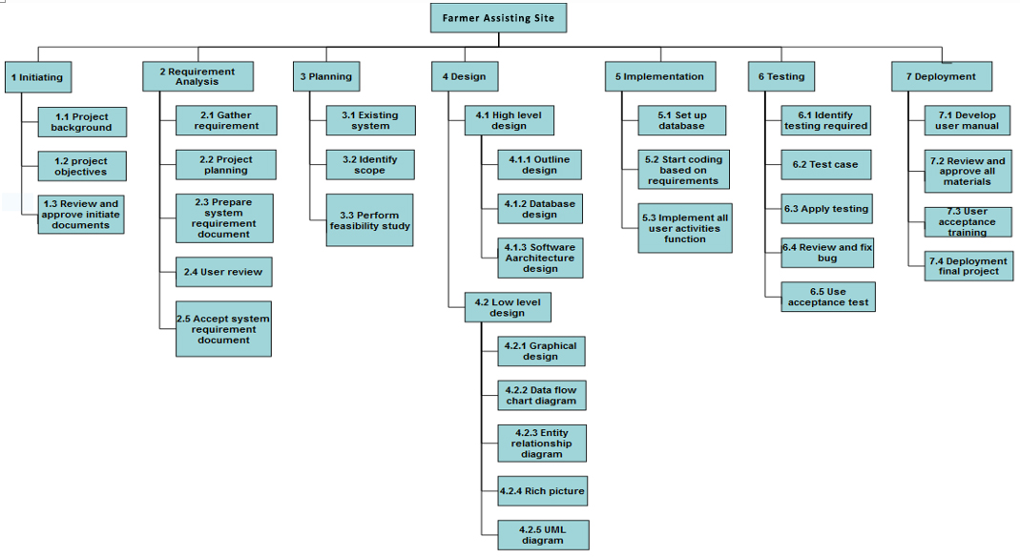

Figure 3.1 1 Work Breakdown Structure

## Process/Activity wise Time Distribution

The time distribution determines the approximate time taken to complete the project successfully, as seen in the critical path process timeline below.The critical path in a project schedule is the longest series of tasks that must be performed on time for the project to be completed on time.vA critical path activity cannot begin until the preceding activity is completed. A project is well-defined task, which is a collection of several operations done in order to achieve a goal.

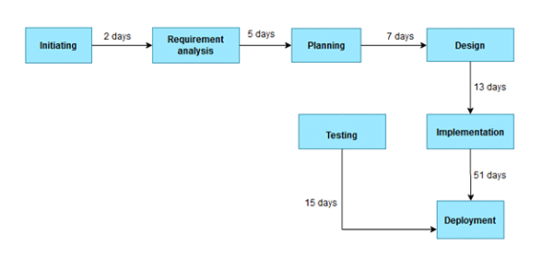

Figure 3.1 2 Time Distribution

## Gantt Chart

For this project, a Gantt chart was used in the planning phase of the application. Gantt charts are commonly used for tracking project schedules, and they are especially useful in project management. To put it simply, they illustrate and allow us to know what needs to be done, and when it needs to be done. Gantt charts are also able to show us additional information regarding the different tasks or sections of a project, such as how far have tasks progresses, how a group of tasks might depend or other groups of tasks, how important several tasks are, and resources are being used within a project. Simply put, a Gantt chart is a bar chart that provides a visual view of tasks scheduled over time. [2]

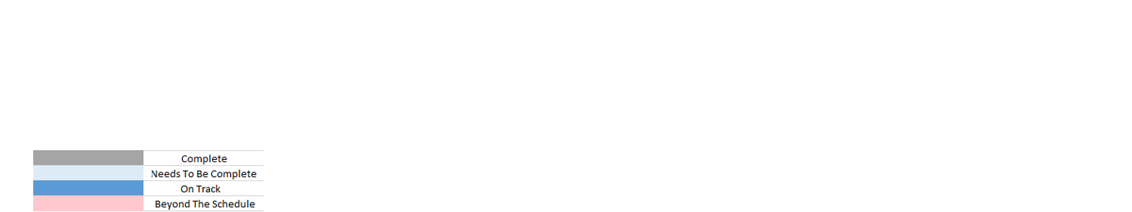

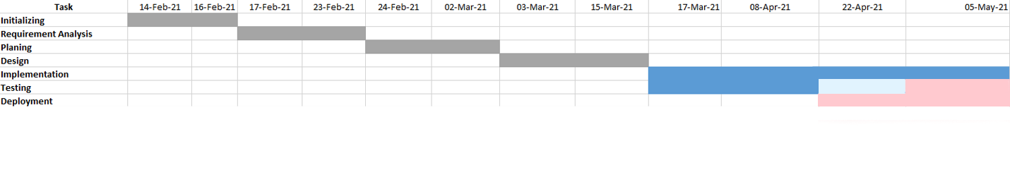

Figure 3.1 3 Gantt Chart

## Process/Activity wise Resource Allocation

The developers are the most important resource for this project, followed by the office computers and the servers needed for the project's implementation. Any employee of the organization is seen as a resource, so each has been given a specific task with a set of deadlines, and they have all worked together to complete the job. [3] Following are the details of every step of the project

* **Initializing**: This is the first period of the project, where the idea of the project was presented by the CEO of the company. Since this was a in-house product, no delay was made and the paperwork for the project was started.
* **Requirement** **Analysis**: During the first few weeks the CEO and the developers discussed the entire requirements for the completion of the project. For example, Computer specifications, software/tech to be used to build the application, features and developers required.
* **Planning**: In this section of the development process, the developers and the CEO engaged in hours of discussion of how this project should be built from top to bottom, the approaches to be taken, creating smaller goals and setting deadlines for them.
* **Design**: In this phase few graphic designers were hired for designing the web pages of the application as well as the management team started working on the high level and low level diagrams for the project in order the get the bigger picture on sight.
* **Implementation**: At this stage, the designs for the web pages were complete and the developers started working on writing the code for the front end and backend of the application, while the management team kept regulating whether all the deadlines were maintained.
* **Testing**: Testing started as soon as a feature was added to the site. Hence simultaneously the testing was being carried out by the developers. At the end of the implementation phase unit testing for the application started.
* **Deployment**: After the testing was truly completed, the team realized that it was behind schedule. For deployment, a VPS (Virtual Private Server) and a domain was bought to deploy the application on a live server.

## Estimated Costing

|  |  |
| --- | --- |
| Requirements | Amount (BDT) |
| Salary(3 months) | 45,000/= |
| Computer (1) | 60,000/= |
| Printer (1) | 7,500/= |
| Server (1 year) | 5000/= |
| Internet Bill (3 months) | 3600/= |
| Subtotal | 126100/= |

Table 3.1 1 Cost Estimation

# **Chapter 4 Methodology**

The study mainly focuses on the development of Farmer assisting system. To develop the web application we followed Agile Methodology. The Agile model is a sequential design process, often used in software development processes. It takes the fundamental process activities of specification, development, validation, and evolution and represents them as separate process phases such as requirements specification, software design, implementation, testing, and so on. [4]

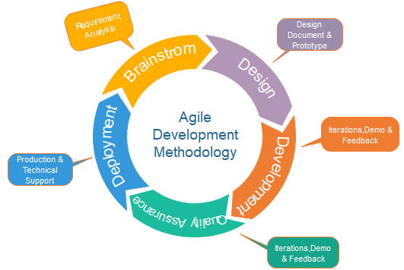

Figure 4.1 1 Agile Development

## 4.1 Why Agile for this project?

The primary benefit of agile software development is that it allows software to be released in iterations. Iterative releases improve efficiency by allowing teams to find and fix defects and align expectation early on. They also allow users to realize software benefits earlier, with frequent incremental improvements. When the development process began there were lack of information in the requirement section of the project, which eventually got added up in the future. As new features and updates on design patterns got updated the design team implemented them in a progressive manner much like what the Agile methodology suggests.

## 4.2 Agile Implementation

The entire plan was decided when determining the requirements during the planning phase, how the development team made sure they divide all the work according to daily basis. Every day some of the coding section of the project would be implemented and at the end of the day a meeting would be conducting between the development team and the management committee to make sure all functionalities that had been implemented throughout the day, was valid and up to the standards as well as the requirements, any changes suggested could be implemented accordingly

# **Chapter 5 Body of the Project**

## 5.1 Work Description

As a member of the development for the project, I had contributed to both the front end and the backend of the application. Even though I had to no part in the design and requirement analysis of the project, The front end built with the HTML 5, CSS 3, and BOOTSTRAP 4, JQuery framework of JavaScript language and for the backend using the PHP. Every day a target of the tasks to be completed throughout the day would have been appointed to me, and at the end of the work day those targets needed to be fulfilled and explained properly.

## 5.2 Client Requirement Analysis

### 5.2.1 Introduction

From the initiation of any project, it is very important to know who the client is for the application, its users, admins and the management operating the entire system. Since the application is only for in-house uses and suggested by the CEO, the client for the application was the CEO and all of my office colleague. Keeping that in mind, I had to think of ways to make the application as user friendly as possible and also how should the application be in a responsive state. Here all the shareholders, the CEO of the company and other developers engaged in meetings and carried out several methods to achieve a complete understanding of the application that was required to build. The methods include:

• Surveys & Questionnaires

• Group Interviews

• Developing a prototype

• Document Analysis

### 5.2.2 Surveys & Questionnaire

Surveys are useful in describing the characteristics of a large population. No other research method can provide this broad capability, which ensures a more accurate sample to gather targeted results in which to draw conclusions and make important decisions [10]. In this case, the survey was conducted between my office employee and I also conduct with some others office employee to truly understand the demand, functionalities and feasibility of the application to be built. The questionnaires are attached to Appendix- A.

### 5.2.3 Group Interviews

As an in-house product, the client interviews conducted were limited to the head of the company and the development team. To get a greater sense and to get the bigger picture of the application the interview question were conducted in two different methods.

•**Close ended questions:** These are question types that ask respondents to choose from a distinct set of pre-defined responses, such as “yes/no” or among set multiple choice questions. In a typical scenario, closed-ended questions are used to gather quantitative data from respondents.

•**Open ended questions:** These are question types that allow respondents to answer in open text format so that they can answer based on their complete knowledge, feeling, and understanding. It means that the response to this question is not limited to a set of options. In a typical scenario, open-ended questions are used to gather qualitative data from respondents.

### 5.2.4 Prototype

Before a full application can be developed, a prototype of the application is developed. The prototype goes under rigorous testing, design tests and UI checked by the client. The data and information obtained from the surveys and interviews were used to develop the prototype. On approval from the client, using this prototypes software developers can then begin to actually work on the whole application. Since an agile methodology was being followed, any design or UI changes can be adjusted accordingly.

### 5.2.5 Conclusion from Research and Analysis

From the surveys and interviews conducted, it is quite clear that the demand for such an online market place is really necessary, a platform for all farmers to look for a start in their prosperous careers. The according to the survey it is seen that the application will mostly be used for searching goods and Selling. On the other hand, from the interviews that company views to generate good revenue from functionalities such as selling goods ,livestock etc .Down below are detailed descriptions for the application. All the roles and their work summary is listed down:

**Admin:**

• View all user data.

• Has full support and conduct any CRUD operation.

• Register a new user.

• Upload a new product.

• Keep track of products and users.

**Users:**

• View own information.

• Can change self-data.

• Smooth communication with admin through system.

• Upload a new product.

• View products.

## 5.2 System Analysis

System analysis is conducted for the purpose of studying a system or its parts in order to identify its objectives. It is a problem solving technique that improves the system and ensures that all the components of the system work efficiently to accomplish their purpose. [5]

### 5.2.1 Six Element Analysis

|  |  |  |  |  |  |
| --- | --- | --- | --- | --- | --- |
| Process | Human | Hardware (Computing) | Software | Database | Network |
| Login/ Register | Enter email & password | Keyboard, mouse, computer | Web browser | Stores register data and retrieves login data | Internet |
| Update  User | Select User and enter details | Keyboard, mouse, computer | Web browser | Update  User details | Internet |
| Delete  User | Select User | Keyboard, mouse, computer | Web browser | Delete User from database | Internet |
| Upload Product | Enter Product details | Keyboard, mouse, computer | Web browser | Stores Product details | Internet |
| Update Product | Select Product and enter details | Keyboard, mouse, computer | Web browser | Update details | Internet |
| Delete Product | Select Product | Keyboard, mouse, computer | Web browser | Delete Product from database | Internet |

Table 5.1 1 Six Element Analysis

### 5.2.2 Feasibility Analysis

As the name implies, a feasibility analysis is used to determine the viability of an idea, such as ensuring a project is legally and technically feasible as well as economically justifiable. It tells us whether a project is worth the investment—in some cases, a project may not be doable. There can be many reasons for this, including requiring too many resources, which not only prevents those resources from performing other tasks but also may cost more than an organization would earn back by taking on a project that isn’t profitable. [6]Feasibility study is carried out based on many purposes to analyze whether software product will be right in terms of development, implantation, contribution of project to the organization etc. There are different types of feasibility studies that are conducted such as:

**Technical Feasibility:** In Technical Feasibility current resources both hardware, software along with required technology are analyzed and assessed to develop project. Questions such ‘Is the application upgradable?’, ‘Technical capabilities and skills of the developers?’ are answered in this section. For this current applications the scalability depends on the number of users of the application, since it is a module based application any addition of a module can easily be added or removed if required. A downside of the program is that the application has become very technical, therefore non-technical users might have a harder time to understand the program completely.

**Operational Feasibility:** It assesses the extent to which the required software performs a series of steps to solve business problems and user requirements. This feasibility is dependent on human resources (software development team) and involves visualizing whether the software will operate after it is developed and be operative once it is installed.The major users of the application are the freelancers, one of the most critical barrier is the language barrier, the application is developed completely in English, hence without understanding the language it should be harder for the user to guide through the program specially in the rural parts of the country.

**Economic Feasibility:**This feasibility study determines whether the required software is capable of generating financial gains for an organization. It involves the cost incurred on the software development team, estimated cost of hardware and software, cost of performing feasibility study, and so on. After this study is conducted it is seen that to make it a profitable business for the Bengal Software company, there needs to be sales in templates that are uploaded at least 10 a week. Other mode of revenue generation includes the selling of tutorials and the most important of all keeping a cut of all the projects that have been developed by a freelancer through this application.

### 5.2.3 Problem Solution Analysis

Problem analysis is the process of understanding and defining the problem to be solved. Problem solving identifies solutions that conform to the needs and constrains of the problem. Much of what is done in designing and building information systems is to solve problems, even though the objective of the system may be seen as improving existing systems or taking advantage of market opportunities.

**Problem 1:Less number of defined requirements.**

**Definition:** At the start of the project, when the requirements for the project was set, the survey and questionnaire did not involve too many people for the project. The sample size for the survey was low since I could not reach my targeted people.

**Solution:** More participants needed to participate in the survey that was conducted, the application has to be viewed through the eyes of any possible farmers.

**Problem 2: No defined process for testing.**

**Definition:** Even though the development team has great abilities with development phase, but there were no testing or SQA team, hence the testing had to be done by the development team as a result due to lack of experience no proper testing process was defined.

**Solution:** An experienced SQA professional was hired during the development phase of the project. His expertise led to the development of a testing process which is defined in the next chapter

### 5.2.4 Effect and Constraints Analysis

A constraint is a restriction on the degree of freedom a company can have in providing a solution. Constraints are effectively global requirements, such as limited development resources or a decision by senior management that restricts the way the development team develop a system. Constraints can be economic, political, technical, or environmental and pertain to project resources, schedule, target environment, or to the system itself. Some of the constraints and its effects are described below:

**Budget Effect:** This constraint has critical effect on how many employees for the project are hired and for how long the project can continue to be developed before reaching a conclusion to deadline.

**Time Effect:** Both the budget and time constraint are interrelated to each other. Time strictly depends of the budget of the company for the particular project. For this project the project was given a time of 4 months and a deadline of 5th of May was decided to be the deadline.

**Scope Effect:** Scope defines whether the requirements set for the project are met. During the development phase the developers needs to keep a close eye on the requirements ofthe project, if a deadline is too near the scope of the project can be stretched and delivered on a later date. This restricts the development team and has to undergo regular discussions, reviews and meetings to make sure the quality is up to the mark.

## 5.3 System Design

Designing is very crucial for the software development field, because it guides you throughout the process of how the work flow will be. In M-Worlds we have contributed to designing and held design as one of the major operations of the project. However, over time as predicted the designs had to be changed and re-constructed while facing many changes in the system. Basically there are a few steps that are needed to be followed in the Development stage.

### 5.3.1 Rich Picture

A Rich Picture is a way to explore, acknowledge and define a situation and express it through diagrams to create a preliminary mental model. A rich picture helps to open discussion and come to a broad, shared understanding of a situation. [7] In the following rich picture shows the summed up activities of the three different user groups of the system namely Admin, farmer, and Buyer. All the users groups has to login and register except admin who can willingly ban or add a user from the group and has all the power to view all data. Farmer can sell any kind of goods in here. Buyers can also get any product provided by the farmers.

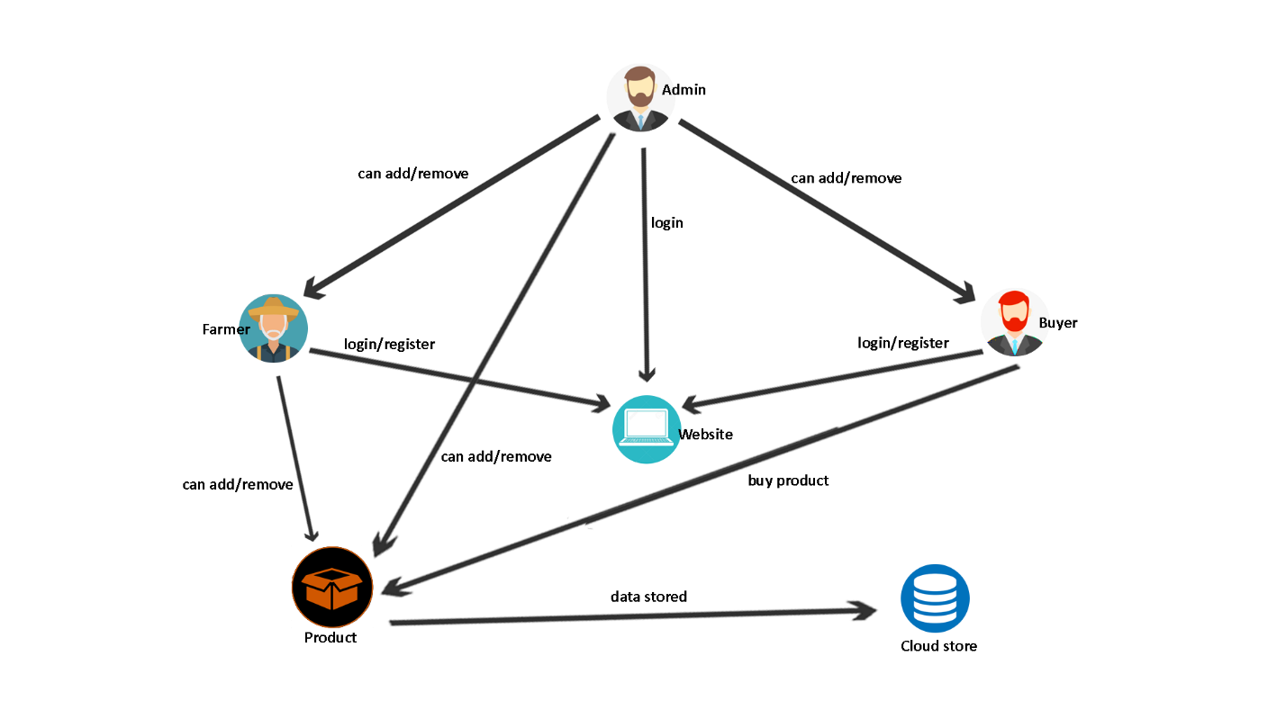

Figure5.1 1 Rich Picture

### 5.3.2 UML Diagrams

A UML diagram is a diagram based on the UML (Unified Modeling Language) with the purpose of visually representing a system along with its main actors, roles, actions, artifacts or classes, in order to better understand, alter, maintain, or document information about the system. So, UML is a way of visualizing a software program using a collection of diagrams . [8] In this section, the activity diagram for all the user groups is shown, Activity diagram is essentially an advanced version of flow chart that modeling the flow from one activity to another activity.

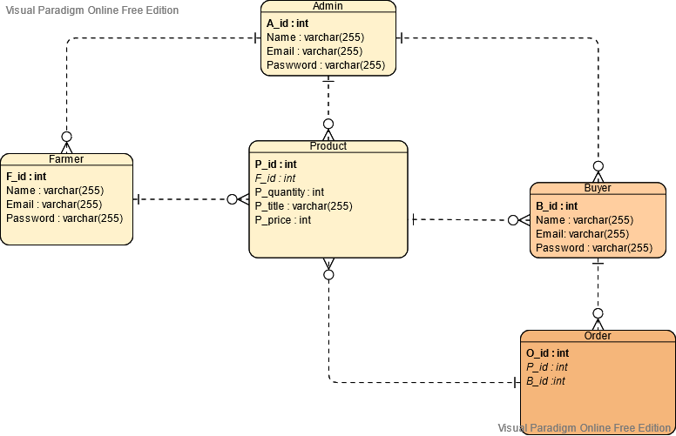

Figure5.1 2 Entity relationship Diagram

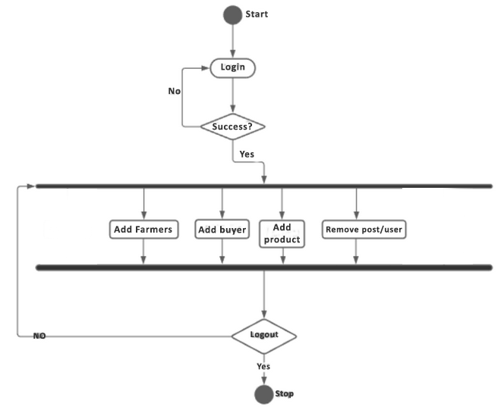

Figure5.1 3 Activity Diagram for admin

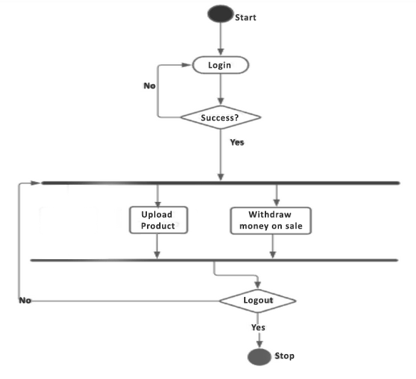

Figure5.1 4 Activity Diagram for farmer

**Activity diagram for buyer**

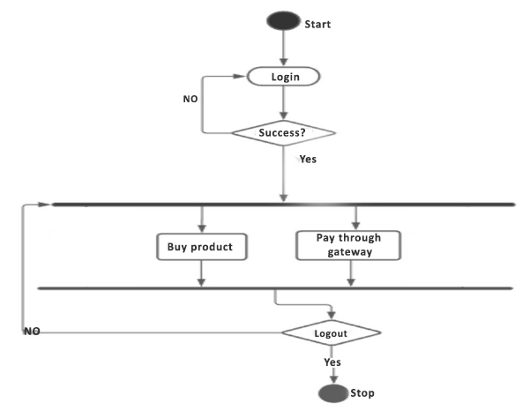

Figure5.1 5 Activity Diagram for buyer

**Use case diagram for admin**

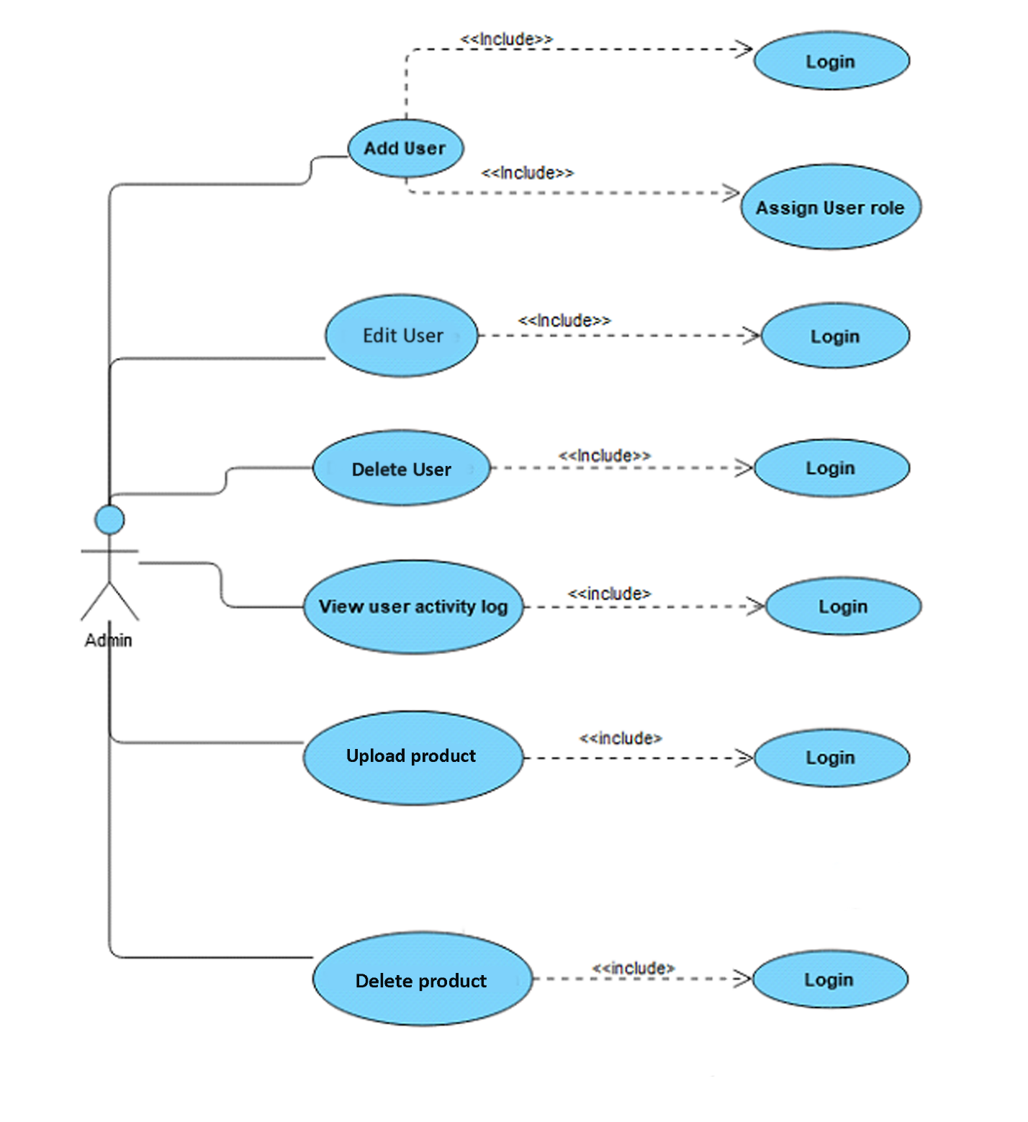

Figure5.1 6 Use case diagram for admin

**Use case diagram for farmer**

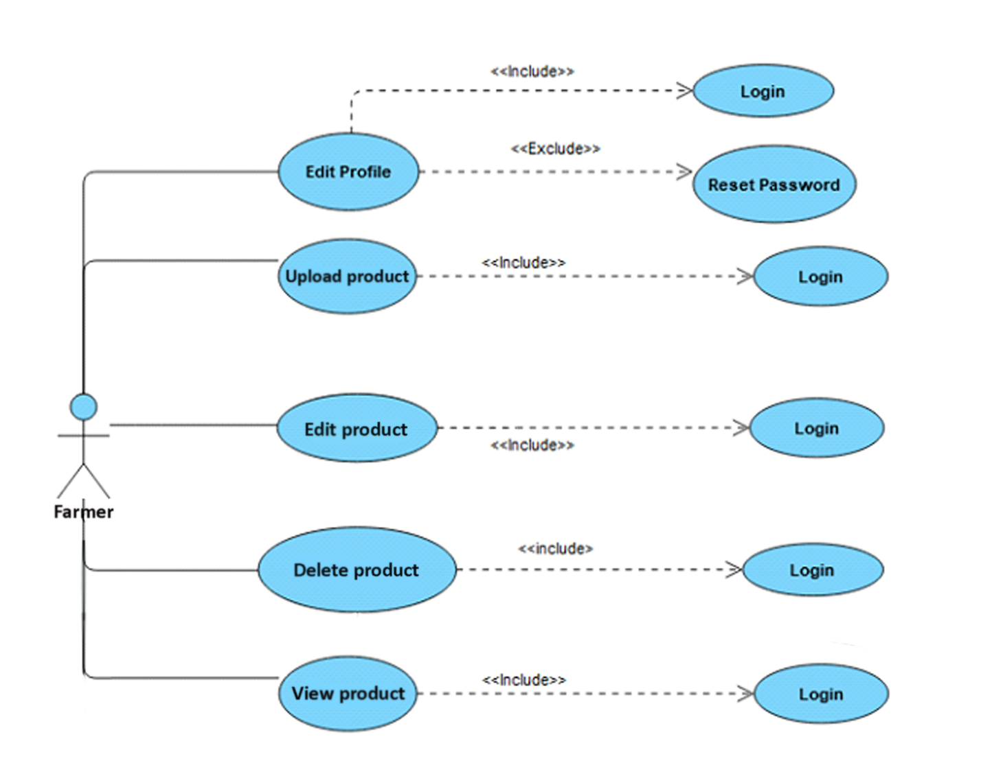

Figure5.1 7 Use case diagram for farmer

**Class Diagram**

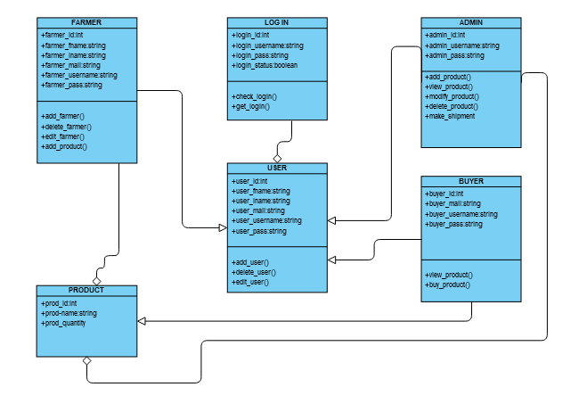

Figure5.1 8 Class Diagram

### 5.3.3 Functional and Non-Functional Requirements

#### 5.3.3.1 Functional requirements

The functional requirement is that it essentially specifies something a system should do**.** The Functional Requirements are the operations and activities that a system must be able to perform.

**Authentication**

* Login- The user can login to the site with his/her username and password.
* Logout- The user can log out from the site.
* Login failure- If the user does not exist in the database or the user has not yet being authorized by the admin.

**Process Data**

* Display- User with defined roles can display the content of the database. Admin can not only see his/her personal information but also user’s information.
* Edit- Admin can edit all information related to all users’ .

**Product**

* Upload product- The user can also be able to fill in products details in the appropriate fields.
* Product approval- The admin can be able to approve products viewing quantity,quality,etc.

#### 5.3.3.1 Non Functional requirements

Non-functional requirements are often called "quality attributes" of a system. A non-functional requirement (NFR) is a requirement that specifies criteria that can be used to judge the operation of a system. Here, according to this website Non Functional Requirements are discussed below. Simply said, a non-functional requirement is a specification that describes the system’s operation capabilities and constraints that enhance its functionality. [9] The system will be fully secured for all users. No personal information will be leaked from the database. We will try to give maximum level of security. Every users password will encrypted s that admin cannot know the password. Only users can change their password and access to their dashboard.

**Performance requirements**

There is no restriction on the number of the users to be added to the database.

**Hardware requirements**

EMS should be able to work on a computer with the following minimum hardware specifications:

OS: Windows XP/Vista/7/8/10

CPU: Pentium III (700MHz) and above

Memory: 512 MB and above

Capacity: 4GB of hard drive

Others: Network interface card, mouse, keyboard, and monitor.

**Software requirements**

Since it is a web-based application, internet connection must be established.

The sites personal database model will support MySQL environment as DBMS.

## 5.4 Product Features

**Login/registration:** Like any other web application that contains user systems, login and registration is the most common features of any application. Admin can register a new farmer and buyer and admin,farmer and employee can login with correct password.

**Update information:** Admin can change farmer’s and buyer’s information.

**Upload product:** Admin can upload a product for a farmer. Both can chat about the description.

**Update product information:** Admin can change farmer’s product information.

**Record of all information:** The system will keep record of all the data starting from farmer’s information, chat with buyer, product sale report , and etc. So there aren’t possibilities of losing anything.

**Time efficiency:** The normal method needs a great deal of time for third parties involvement and other schemes. The admin can generate statically reported data from the system directly in the forms of diagram.

### 5.4.1 Input

The following table shows the process and the fields required for the inputs of the corresponding process.

5.1: Input table with their fields

|  |  |
| --- | --- |
| Process | Fields type |
| Login | Email- string  Password- string |
| Registration | Name - string  Email - string  Password - string |
| Edit profile | Name - string  Email - string  Password - string |
| Upload product | Name- String  Product details- string  Quantity - string |
| Edit product | Name- String  Product details- string  Quantity - string |
| Delete product | Name- string  Number of leave- string  Time - string |

Table 5.1 2 Input tables with Field

### 5.4.2 Output

The output of the process listed below

5.2: Output table with their fields

|  |  |
| --- | --- |
| Process | Output |
| Login | On success- Redirect to user dashboard.  On failure- Show error message at top “Please enter correct id or password” at top. |
| Registration | On success- Show success message “Registration successfully done” at top.  On failure- Show error message “Registration not done” at top and under the fields input. |
| Edit profile | On success- Show success message “Updated data successfully” at top.  On failure- Show error message “Data not updated “at top. |
| Upload product | On success- Show success message “Product uploaded successfully” at top.  On failure - Show error message “Somethings wrong! Check again.” at top. |
| Edit product | On success- Show success message “Product updated successfully” at top.  On failure - Show error message “Somethings wrong! Try again.” at top. |
| Delete product | On success- Show success message “Deleted product successfully” at top.  On failure - Show error message “Somethings wrong! Try again.” at top. |

Table 5.1 3 Output table with Field

### 5.4.3 Architecture

The development phase of this application was mostly done by Php , MySql, Apache, Html, etc.

**HTML5**: Hypertext Markup Language (HTML) is the set of markup symbols or codes inserted into a file intended for display on the Internet. The markup tells web browsers how to display a web page's words and images.HTML5 is the latest version of HTML.

**CSS3:** Cascading Style Sheets (CSS) is a language that is used to illustrate the look, style, and format of a document written in any markup language. In simple words, it is used to style and organize the layout of Web pages. CSS3 is the latest version of an earlier CSS version, CSS2.

**BOTSTRAP4:** Bootstrap 4 is the newest version of Bootstrap, which is the most popular HTML, CSS, and JavaScript framework for developing responsive, mobile-first websites.

**PHP:** PHP is an open source server side scripting language, it is platform independent, meaning it can work on all major operating systems. PHP supports many types of databases including MySQL and is supported by a large community of users and developers. PHP is an excellent choice for developing web based systems because it’s an open source technology and has a large community of users and developers, this makes PHP a language that is easy to learn and understand, furthermore coding solutions and bugs are resolved quickly. The fact that PHP is platform independent gives the developer the freedom to develop an application without worrying about the operating system on a user’s machine. PHP has the ability to integrate with most web technologies thus it can be used as middleware.

**Apache:** This is an open source software that handles almost 70 percent of all websites available today. Most of the web-based applications use Apache as their default Web Server environment.

**MySQL:** MySQL stands for My Structured Query Language. It is the world’s most popular open source relational DBMS. MySQL is available for free under the GNU General Public License for open source benefits/reasons related to development. Initially MySQL was free and some versions of it are still free though if you desire to use MySQL for commercial purposes you will need to purchase a license. It is non-proprietary, easily extensible and platform independent. Its downside is that it lacks a graphical user interface; therefore you need to know how the database works to make the most efficient use of it.

## 5.5 Test Case

Software testing is a process, to evaluate the functionality of a software application with an intent to find whether the developed software met the specified requirements or not and to identify the defects to ensure that the product is defect-free in order to produce a quality product. The main purpose is of identifying any errors, gaps or missing requirement versus the actual requirement.

The testing phase for this application started right in between the implementation phase. The Bengal team worked to make sure every time a functionality was implemented it was tested thoroughly, following a testing pattern called test driven development or TDD. A testing strategy was followed described in the next chapter.

### 5.5.1 Testing Strategy

The main objective of software testing is to design the tests in such a way that it systematically finds different types of errors without taking much time and effort so that less time is required for the development of the software. The steps used are detailed below:

* Before testing starts, the requirements gathered are understood and made a list in a quantifiable manner.
* The objectives of the testing are identified and developed. This step was mainly used to identify test cases.
* The user groups of the application are identified and their functionalities.
* Before testing, effective formal reviews are used as a filter.
* Conduction of formal technical reviews to evaluate the nature, quality or ability of the test strategy and test cases.

### 5.5.2 Testing Analysis

|  |  |  |  |  |  |  |  |
| --- | --- | --- | --- | --- | --- | --- | --- |
| Test case | Test Purpose | Pre-condition | Test steps | Expected outcome | Actual result | Status | Remark |
| Login | Check username and  Password | 1)Users must have stable internet connection  2)User must enter credentials | 1) Enter credentials in the field provided  2)Enter the login button | Grant access to the users dashboard | User successfully logs into the system upon submission of correct login credentials. | Pass | None |
| Registration | To ensure that a new user is added to the system successfully | 1)Users must have stable internet connection  2)User must enter credentials  3) admin must be logged in | 1) Enter credentials in the field provided  2)Enter the register button | 1) Show success message “registration done successfully”  2) Failure message shown “registration not done” and indicate under the input | Message shown “Registration done successfully” | pass | None |
| Edit user details | To ensure that once different details are provided on the edit  Personal details form and  submitted,  these details are altered in the database to reflect the recent  changes | 1)Users must have stable internet connection  2) users must be logged in  3) users must enter new credentials | 1) Enter new credentials in the field provided  2)Enter the update button | 1) New user should be successfully added to the system and show success message “Data updated successfully”  2) Failure message shown “data not updated” | Message shown “Updated data successfully” | pass | None |
| Upload product | To test product upload for user | 1)users must have stable internet connection  2) User must enter details | 1) Enter details in the field provided  2)Enter the upload button | 1) Show success message “Product uploaded successfully”  2) Failure message shown “There is a problem in product upload” | Show success message “Product uploaded successfully” | pass | None |

Table 5.1 4 Test case

# **Chapter 6 Results & Analysis**

## 6.1 Overview

I followed some steps and researched existing sites to gather knowledge how can i execute the project. At first I have discussed with the CEO, and office employee then made a plan which was discussed with respected faculty member. Carefully made steps were taken to understand the system we are trying to build. Once all the discussions had been ended then a general idea of the project was developed. Also many suggestions and advice were taken from CEO and employees which made clear the functionalities that should be involved in a system like this. After that we finalized how the system interface will look , what tech is going to be used, and the data that was needed was determined. Finally came the prototype with all the data where I tried my best to implement all the functionalities. Because of the COVID-19 situation we have lost a lot of time where I have made some sacrifices in the functionality section and also tried to implement everything I have learnt.

## 6.2 Results from interviews

From the interview, initially it was quite clear what we wanted to create for our in house uses. From the interviews the functionalities of the application was being identified. Simple questions such as what the buyer/farmer really wants and how to make the application more user friendly was cleared through these interviews. From these interviews it was very clear that in this time during the pandemic it would be a great help for the farmer if he can sell his product online when there is a chance it will not be sold and also can be wasted. Also the buyer can easily get the product from nearby farmer which will be cheap and the product can be investigated by the buyer if he wants to. It can be a successful project if executed perfectly.

## 6.3 Conclusion

Everything is being digitalized now a days. In this pandemic we have seen a huge amount of online stores and delivery services grow exponentially. Everyone wants to smartly handle their business and want to use online platform to boost their business. Because using the online platform and delivery services they can reach to a vast amount of people . Especially local and individuals can get the boost they need from online. As a result this project was created to directly help the farmers by cutting the middleman or handler which will be very beneficial.

# **Chapter 7 Project as Engineering Problem Analysis**

## 7.1 Sustainability of the Project/Work

Thinking about the future, the company has made huge plans to make sure enough revenue is generated. Initially the goal is to make sure all the upcoming graduates gets involved in the software. The next plan is to target the rural areas throughout the country. Therefore this business plan should bring in more users to the application. Eventually more users means more revenue will be generated through this application. Finally the bigger picture for the company is to become the lights of marketplace for farmers. The program is made such that the application is scalable, any new functionalities by the developers can easily be integrated to the application.

## 7.2 Social and Environmental Effects and Analysis

Agriculture has consistently been the largest sector in Bangladesh, as in several other developing economies. About 50 percent of the population are employed in this sector and about 70 percent people overall depend on agriculture for their livelihood. A significant proportion of the poor relies on agriculture as the key source of income and employment. So,If we can optimize and ease the processes like transportation of goods and take the buyers directly to the farmer we can further boost the economy also the farmers livelihood. Also, adding features as the farmer can directly apply loan from the site, can add delivery system, etc that can have a big affect on these farmers.

## 7.3 Addressing Ethics and Ethical Issues

The system will be fully secured for all users. No personal information will be leaked from the database. We will try to give maximum level of security. Every users password will encrypted so that admin cannot know the password. Only users can change their password and access to their dashboard.

# **Chapter 8 Lesson Learned**

## 8.1 Problems faced during the project

During the project we have faced many problems. Clarity is one of the most important requirements for the successful completion of the project and the lack of it creates several project management issues. A study states that about 39% of projects fail due to the lack of project planning and a clearly defined goal. During the first month it was hard to discover how to solve the Problem farmers face and how to resolve them. Also there was other problems like figuring out how the interface will look and how to make it very simple and user friendly. There were some time wasted on how we will implement the idea into a site.

Most of the time was wasted on discovering how the site will look and what functionality will there be. Also during the pandemic it was very difficult to keep up with work and the project. As a result the progress was slowed down . During the 1 month lockdown on may it was very difficult to communicate as we could not go to the office and discuss on how to implement the next steps.

## 8.2 Solution to those problems

Most of those problems were solvable if we could regularly discuss problems with our seniors. But as we were in a lockdown we had to google and see existing sites to solve our problems. Also we have seen other peoples work and research paper on how to solve specific problems during a project and lots of trying and failing also solved lot of problems.

# **Chapter 9 Future Work & Conclusion**

## 9.1 Future Works

This software will undergo a radical change in the future. So, The work doesn’t stop here. For the future we will add more feature in this application . Some of them are listed here-

* **Internal Chat**

The importance of this is very high. Most of the times the buyer will feel safe if he can have a conversation with the farmer. In this part they can resolve any queries or negotiations.

* **Integrated Delivery System**

The delivery system will be a great help to the farmers because if it can be integrated farmers can give a small fee and will be able to use the delivery system to deliver product to buyer quickly.

* **Banking System**

Also if there was a system where farmers can apply for bank loan for specific crops and other needs it will be a great help to the farmers.

* **Blog page For tips & tricks**

A Blog page where all the farmers can share their problems and how they have resolved it. Also it can be used for learning do’s and don’ts or tricks for how to grow ,what to grow, killing pest, etc.

* **Rating**

Rating will also be integrated to avoid fraudulent activities . So buyer can check farmers rating.

## 9.2 Conclusion

I worked on a web application which has a goal to improve existing situation of the farmers during my internship at Bengal Software. This helps me to gain knowledge on how a web application has to be handled . This system is designed for saving money, time and a lot of wastage of our crops. If we can further improve the system we think this can be a great software for farmers who right now are suffering the most from this pandemic.

It has been a great opportunity for me to work in Bengal Software as a web application developer. The internship program here was 3 months but the last one month was lost due to pandemic and quarantine. But the first two months guidance here has been my first step to the world of information technology. My experience here was full of knowledge about the development process and also the job market. I have learned how to handle different requirement for the software and the best approach to developing it. This program gave me a clear idea about professional life as a web developer, what I must face and how to handle those situations. During internship, I tried to cover my weakness about web development and tried to become a good web developer.

# References

[1] https://www.projectmanager.com/work-breakdown-structure

[2] https://www.projectmanager.com/gantt-chart

[3] https://www.projectengineer.net/the-6-steps-of-resource-allocation/

[4] https://www.guru99.com/agile-scrum-extreme-testing.html

[5] https://www.w3computing.com/systemsanalysis/

[6] https://www.simplilearn.com/feasibility-study-article

[7] https://www.betterevaluation.org/en/evaluation-options/richpictures

[8] https://www.smartdraw.com/uml-diagram/

[9] https://www.altexsoft.com/blog/non-functional-requirements/

# Appendix (UI image)



HOME PAGE

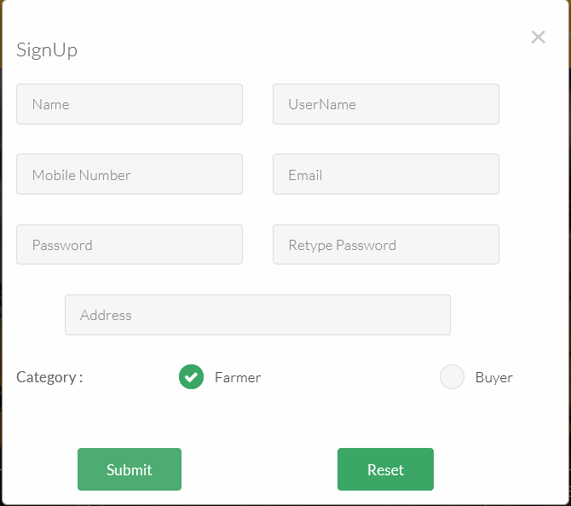

REGISTRATION

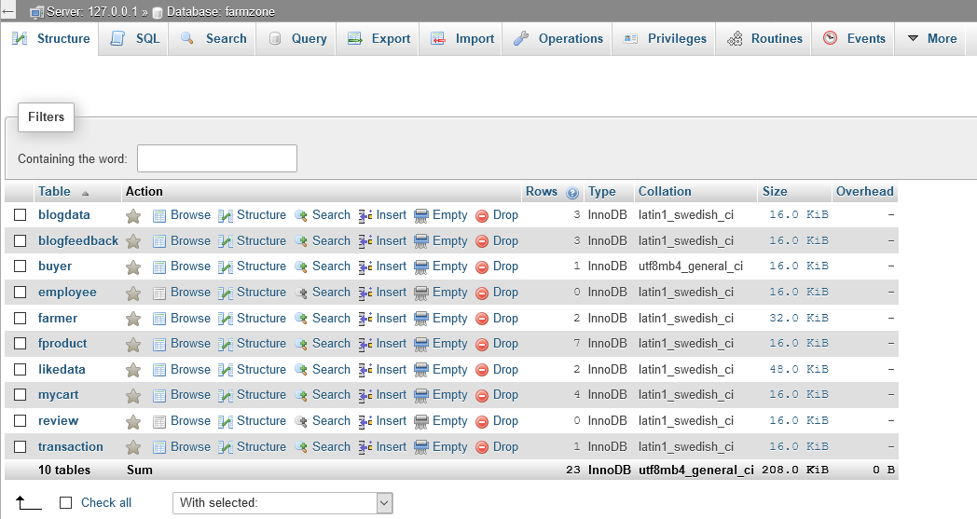

DATABASE